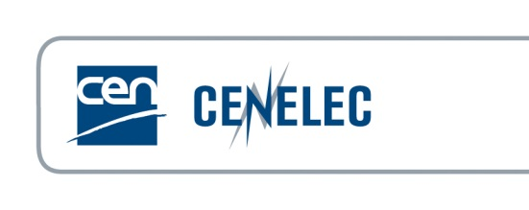
RESEARCH AND STANDARDISATION
RESPONSE FORM for Standardisation groups
Opportunity for standardisation to contribute to the European Partnership on Metrology EPM under Horizon Europe
Objective: to collect standardization needs and suggestions to develop research projects in testing and measurements for the upcoming European Partnership on Metrology* (EPM) calls in 2024
In the frame of the cooperation agreement between CEN-CENELEC and EURAMET,
CEN and CENELEC have been invited by the EURAMET Management to put forward their testing and measurement needs in research for consideration by metrology institutes for future calls under EPM.
Relevant technical groups (sector fora, advisory boards, coordination groups, TCs, WGs...) are invited to contribute with:
- a short introduction or an overview paper of their unaddressed standardization needs for testing and measurement, and
- a contact person (secretary, chair, convenor, liaison officer, etc.) whom proposers for the Potential Research Topics can contact,
by using this Response Form and send it to the STAIR EMPIR secretariat hosted by NEN (Mr Arnoud Muizer) at : empir@nen.nl with a copy to research@cencenelec.eu
Deadline for the consultation: 15 December 2023
Source of the identified need  (identification of TC, WG, etc. incl. title) | CEN/TC 0/WG 0 CLC/TC 0/WG 0  ISO/TC 0/SC 0 / WG 0 IEC/TC 0/SC 0 / WG 0  Other, namely Identification, Title
European entity responsible for submission of the need | CEN/CLC TC #, or National Standardization Organization  Title
Person that can be contacted for more detail | First name and family name  E-mail  Telephone  Country
Title | Title and short scope/description of the need as such
Unaddressed need | Short description of the need as such
Further explanation of need  (TC business plan, road map, formal decision, work item, etc.) | Further explanation on the need, why it shall be filled and why specifically related to standard  Estimated time frame that need shall be fulfilled
Proof of the need by the TC/SC | Indication by the standardization group of its support to use the effective research result is strongly recommended. Indicate a decision or attached minutes that underline that support.
Enclosures | Yes  No
*See more information at: Standards and Metrology and Metrology Partnership website

